Wilhelmina Long

### Clinical Nurse Consultant

Experienced Spinal Unit Clinical Nurse Consultant Grade 3 since 2019, with demonstrated practice in Spinal Nursing for

over 20 years. Skilled in Consultation, Acute Care, Spinal Injuries Nursing Management, Nursing Education, Clinical Leadership, and Customer Service. A transformational and resonant nursing leader on a pathway to Master of Clinical Nursing (Leadership in Practice) via UTAS.

[wilhelmina.long@health.nsw.gov.au](mailto:wilhelmina.long@health.nsw.gov.au)

0497 170 264

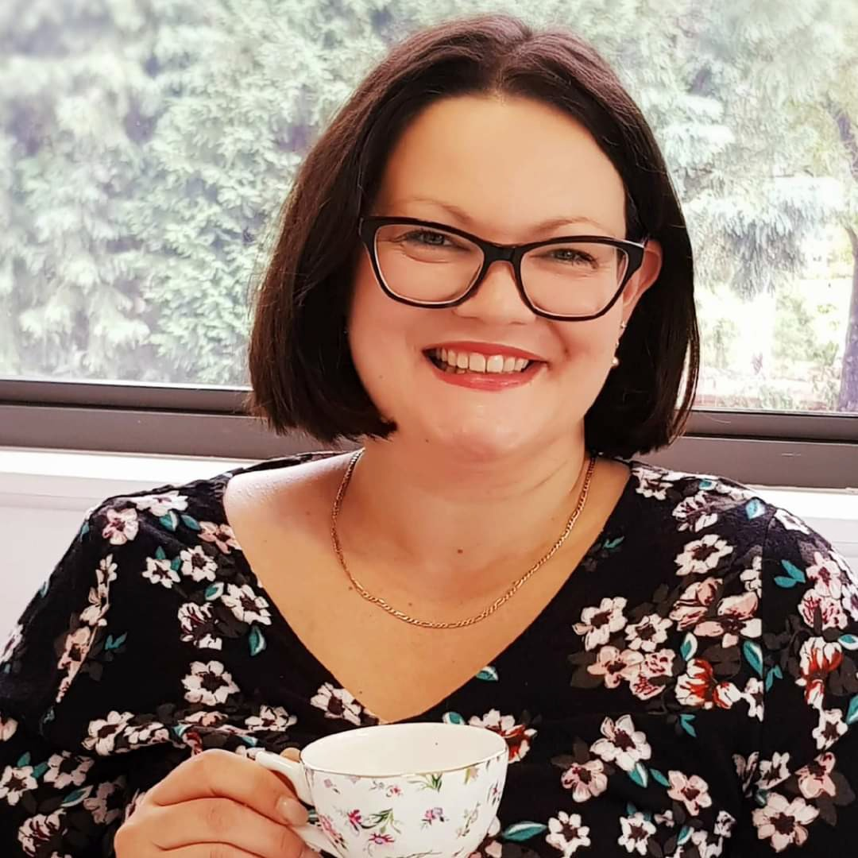

Sydney, Australia  [linkedin.com/in/wilhelmina-long-355610a0](https://www.linkedin.com/in/wilhelmina-long-355610a0/) 

**REFERENCES**

Wendy Brown, NUM3 7E, SIU, RNSH Contact: [Wendy.brown3@health.nsw.gov.au](mailto:Wendy.brown3@health.nsw.gov.au) -

94632751

Dr Jasbeer Kaur, Clinical Director, SIU, RNSH Contact: [Jasbeer.kaur@health.nsw.gov.au](mailto:Jasbeer.kaur@health.nsw.gov.au) - 94631780

Sonia Jones, CNC3, SIU, RNSH Contact: [Sonia.jones1@health.nsw.gov.au](mailto:Sonia.jones1@health.nsw.gov.au) - 94632756

# SOFT SKILLS

Empathetic

Thorough

Approachable

Role-model

SCI networker

Encourage C.O.R.E. values

**WORK**

## Clinical Nurse Consultant Grade 3

### Spinal Injuries Unit, RNSH

*01/2020 – Present St Leonards, Sydney*

*Expert clinical leader and advisor on spinal cord injury (SCI) management. Created Spinal CNC e-referral.

*Provides clinical service and consultancy to MDT, NSW community agencies, community and inpatient medical practitioners, individual patients and those that care for them. Develops, plans, implements, and evaluates care management for patients with complex health care needs due to SCI, both in-reach and outreach.

*Demonstrates computer skills in MS Office. Seeks opportunities for up-skilling and further learning. Maintains My Health Learning at 100%.

*Assists policy development regarding SCI care, reviews policy and procedure as due.

*Provides accessible, direct, tele-health, and phone, consultation and technical support and participates in research and QI projects.

*Assesses products for use on both SIU and with outlying inpatients with SCI and provides appropriate feedback.

*Networks with CNC peers, specialty experts and Health Care peers. Attends relevant courses and conferences in specialty.

*Co-ordinates Spinal Clinics and the annual RNSH SIU Core Course, "Injury to Independence" each year.

*Facilitates and plans complex discharges, especially long-term SIU inpatients: ventilator-dependent tetraplegics.

*Contact: Sonia Jones, CNC3 SIU 7E, 9463 2756*

## Clinical Nurse Specialist

### Royal North Shore Hospital

*02/2002 – Present Spinal Injuries Unit, 7E*

RN8 to Clinical Nurse Specialist, regrading submitted and agreed April 2020, renewed yearly.

*St Leonards, Sydney, NSW*

Manual Handling Resource Person 2009 - present. Implements Hazardous Manual Tasks (HMT) Program and assists with assessment and retraining. Role-model, preceptor, lecturer, and senior clinician.

Presented at annual SIU Core Course, "From Injury to Independence and Beyond." Presents rewritten and reviewed in-service to New Graduates RNs and new starters: "Respiratory Management after SCI," "Spasm & Spasticity after SCI." Presented reviewed "Skin Management after SCI."

Chaired MDT meetings, relieved for NUM, after hours team leader.

*Contact: Wendy Brown, NUM 7E SIU, 99267851*

# SKILLS

CNC3 role experience Research data collector

Preceptor & mentor

CVAD, PCA, VDT VIVA

assessed

# EDUCATION

Auditor

Team Leader Senior clinician

NGT insertion approved

Lecturer

Home ventilator and tracheostomy care trained.

Spinal Cord Injury management

Discharge Planning

**Bachelor of Nursing with Professional Honours (Leadership in Practice)** University of Tasmania

*02/2020 – Present*

Graduate Diploma which articulates directly into the Master of Clinical Nursing (Specialty)

# CERTIFICATES

*Tasmania*

Student Number 551065.

#### AHPRA: Registered Nurse, Division 1 (General), (12/2001 - present).

*NMW0001156557*

#### Certificate of Completion- Manual Handling Assessor (10/2009 - (10/2009).

*Authorised by the Manual Handling Task Force, RNSH and NSLHD.*

# ACHIEVEMENTS

#### Member of NSW Nurses and Midwives' Association (02/2002 - present)

*Member number 248198*

#### Member of Australian College of Nursing (02/2002 - present)

*Member number 65264*

# INTERESTS

Spinal Cord Injuries

Networking

Lecturing/Public Speaking

Law and Ethics

Fundraising

Palliative Care

Further Education

Australian Health

Travel

Fishing

Caravanning

**CONFERENCES AND COURSES**

#### "Injury to Independence and Beyond" (06/2004 – Present)

*Spinal Injuries Unit, RNSH*

Attendee, 2003. Lecturer since 2005. Nationwide and statewide attendees.

#### WHS Manual Handling Resource Person Refresher - Clinical (10/2009 – Present)

*RNSH Work Health Safety*

Refresher day for those who had been trained, what's new with manual handling in NSLHD, new equipment, forms, procedures, and gave an opportunity to trouble-shoot hospital-wide or area-specific issues and discuss ideas.

Taught how to train workers in practical manual handling skills, management of bariatric needs patients and provided a practical manual handling skills refresher.

#### Palliative Care Workshop (11/2018 – 11/2018)

*RNSH Palliative Care specialists and allied team*

Palliative care, organ donation, disease trajectories including spinal cord injury, modern ethical issues.